OCTOBER 5, 2019
GYM OPENS 7:15
COACH/REF MEETING: 7:45

Round one pre-game conference 8:00 all courts
Warm ups: Round 1 & 2 (677) after that (3/3)
POOL PLAY - FIRST ROUND GAMES 8:20

Match Format 2 out of 3 (sets 1&2 25 (27 cap) set 3 -if needed- 15 (17 cap)
ONE TIME OUT / SET

Each team will play all others in pool play format. There is not a bracket portion.
Teams will get their finish seed based on Match record, set record, point differential, head to head and coin flip if needed

Championship to be determined by combining the final seed for boys and girls teams
Ties will be decided using the same formula of combined match record set record point differential and a coin flip
(awards for winning school are limited to 30 total player awards)

South Varsity teams will be providing score book and score board workers. NO Libero tracking will be done beyond scorebook. Teams to supply 2 line judges as assigned.
Game 8 Waukesha South v West – tbd line judges

Home team is listed first on schedule of games

Hospitality Area for coach’s and officials will be open all day. We will have coffee and bagels in the morning. Water, soda, Gatorade will be in the blue cooler all day. Lunch will also be provided to coach’s (limit 2) and officials

Court layout
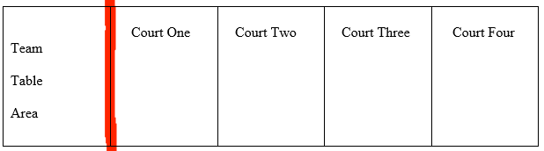

***Tournament T-shirts will be available for sale. These were designed by Frisco Mo and look awesome. Anyone wishing to purchase them can do so for $15.00. We also have a free shipping for all Frisco Mo merchandise as part of the promotion. www.Friscomo.com/stuff use code SOUTHVB for the shipping discount ***
